Registering Candidates and Ordering Learning Materials (2022-23)

The CISI offers two externally assessed units for delivery in schools and colleges via computer-based exams:

- Level 3 Award for Introduction to Securities & Investment – a standalone professional qualification
- Level 2 Award in Fundamentals of Financial Services – a standalone professional qualification

REGISTERING CANDIDATES:

Candidate registrations take place at the start of the academic year, between September and the end of November. This process allows the CISI to create candidate records and to order the relevant learning materials to support their studies.

At the start of an academic year, the centre will be contacted by the schoolsandcolleges@cisi.org to inform them of the registration deadline and the Excel document which should be populated with the relevant information to register students.

The spreadsheet called ‘CISI School and College Student Registrations BLANK’ looks like the see screenshot below.

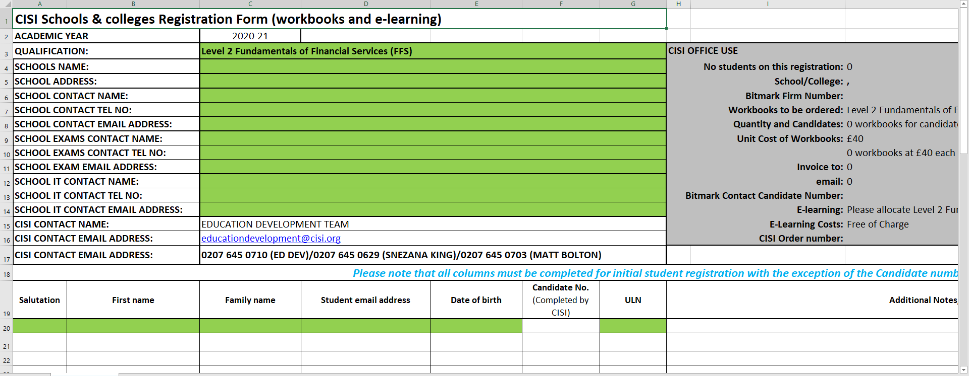

To register candidates, please complete the spreadsheet by:

- Selecting the relevant qualification name that candidates will be studying
- Adding the details of the school and key contacts requested
- Adding the candidates’ details (Salutation, Name, Email address and Date of Birth)

Once the registration spreadsheet has been completed, please password protect the document and send this to the schoolsandcolleges@cisi.org along with the password (in a separate email).

The Schools and Colleges team will register candidates on the CISI system and complete the spreadsheet with the CISI candidate numbers for each student. The completed spreadsheet containing the candidate numbers will be sent back to you, attached in an email to confirm that this has been actioned.

ORDERING LEARNING MATERIALS:

At the same time candidates are registered, workbooks and the relevant e-learning package will be ordered for each candidate.

Please note that if candidates are registered, they are required to have hard-copy workbooks ordered to accompany their studies - charged at £42 per candidate.

Candidates will receive several automated emails from the CISI:
- New Customer Registration – this will provide students with their customer number and details to log-in to ‘MyCISI’ (members portal). Accounts must be activated withing 48-hours of receiving this email.

- Workbook Order Confirmation – Provides a link to a pdf version of the workbook (in addition to the hardcopy that will be sent to the school). The physical workbooks are sent to teachers with a normal lead-time of 7-10 working days following the order being made.

- E-Learning Access Confirmation – Provides a link to the e-learning package for students to use.
Please note that candidates will be unable to access the ‘Revision Express’ e-learning package (free of charge) or ‘MyCISI’ (part of free student membership) if we do not have live email addresses for them when registered.

ACCESSING THE REVISION EXPRESS E-LEARNING TOOL:
Step 1
To access the e-learning product, copy the following web address into the url toolbar:
https://www.cisi.org/cisiweb2/cisi-elearning/cisire
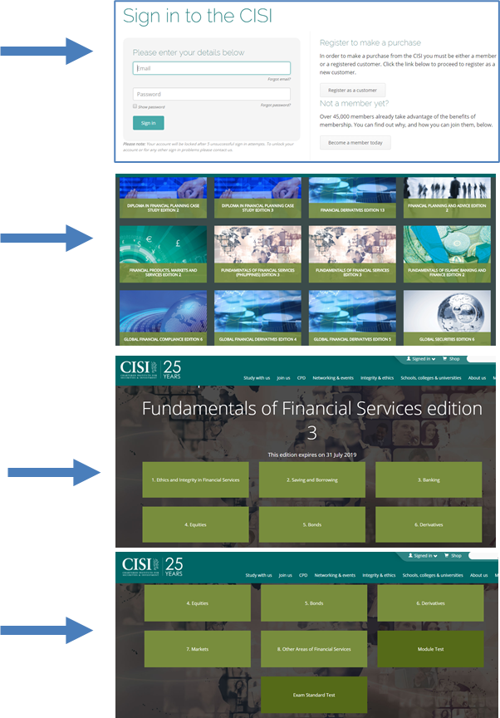
Step 3
Once logged in, you will be able to locate the revision package that your course relates to e.g. Fundamentals of Financial Services.
Once located, click on the icon and this will take you to the course-related content.
Step 4
Once you have selected your course module, you can select individual chapters that you would like to focus on. For each chapter, you can select to take a timed, multiple-choice chapter test at the end of the content.
At the bottom of the chapter selection screen, you can also take an exam standard test which covers the entire qualification content.
Step 2
Log in using your customer reference number and password.
You may need to re-set your password via:
www.cisi.org/password

