  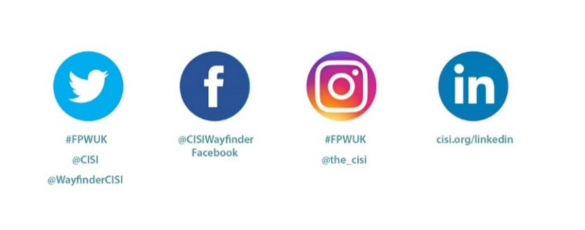  #FPWUK  LIVE YOUR TODAY.  PLAN YOUR TOMORROW. | PRESS RELEASE  XX September 2022  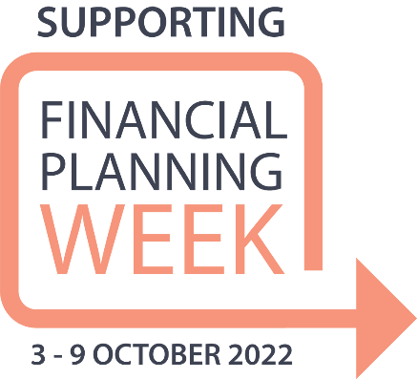

UK public are encouraged to understand their finances better in CISI’s Financial Planning Week 3 - 9 October 2022
#FPWUK

The 2022 UK Financial Planning Week (03-09 October) comes as the cost of living is soaring, inflation and interest rates are rising, and as a new Prime Minister takes up residence in Downing Street. This year the week-long event is about busting myths around financial planning and encouraging conversation around finances. The aim is to empower consumers throughout the UK by raising awareness of the support available from financial planning, this includes help with organising finances and guidance in planning how to reach life goals and dreams.

This initiative is very important to us at [Insert your firm], we value supporting the Chartered Institute for Securities & Investment’s (CISI) Financial Planning Week and will be [Insert your firm’s Financial Planning Week activity/activities], [insert your firm’s webpage, email or telephone number].

The annual campaign, organised by the not-for profit professional body the CISI, is a nationwide initiative aiming to help consumers build financial confidence, combat anxiety and stress about money and deal with life’s challenges around day-to-day financial decisions. The CISI financial planning community, led by CERTIFIED FINANCIAL PLANNER™ professionals, are a great support in sharing the message of this initiative.

The UK public are being encouraged to think about how they feel about their finances, whether they feel they know as much as they could and to understand what meeting with a financial planner involves, to see the life-changing benefits for themselves by visiting financialplanning.cisi.org.

[Insert name, insert your firm, said: “Insert quote XXX XXX XXX”]

Sally Plant, CISI Assistant Director, Financial Planning & Education Development said:
"It has never been more important to get the message out – that financial literacy is an important tool for life, and financial planning is an essential part of wellbeing and mental fitness. Financial Planning Week helps raise awareness about the role of qualified financial planners in helping people from all walks of life, and all ages – and importantly, not just the wealthy – to think ahead and plan for the future."
During Financial Planning Week, financial planners and their firms will be:
- Offering complimentary consultation surgeries
- Providing talks to local schools across the country to share the merits of the financial planning profession as a career
- Sharing their articles, guides and case studies on financialplanning.cisi.org
For further information on our involvement in Financial Planning Week contact [insert name] on [insert email and telephone number]

ends

About Chartered Institute for Securities & Investment

Based in the City of London, the Chartered Institute for Securities & Investment (CISI) is the leading professional body for securities, investment, wealth and financial planning professionals. Dedicated to professionalism since it emerged from the London Stock exchange in 1992, its purpose is to champion lifelong learning and integrity, raising individual standards of knowledge, skills and behaviour globally to enhance public trust and confidence in financial services. The CISI is a global organisation with representative offices in financial centres such as Barcelona, Colombo, Dubai, Dublin, Edinburgh, London, Manila, Mumbai and Nairobi.

